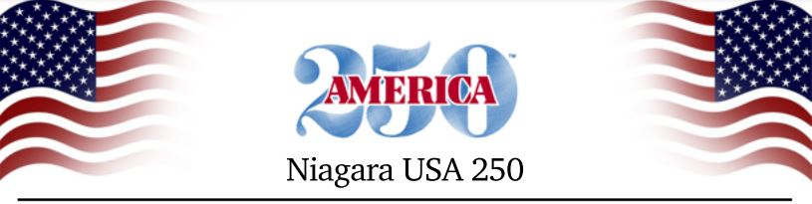
For Immediate Release:
Wednesday, January 24, 2024
Contact: Kevin Schuler
(716) 504-7146
Kevin.schuler@niagaracounty.com

Niagara USA 250 Committee Seeks Local Input

The Niagara County committee charged with organizing local events around America’s 250th birthday – known as a semiquincentennial – that will take place in 2026, is asking municipal officials, heritage organizations and county residents to begin thinking about what their local community may do to recognize the occasion. The Niagara USA 250 Committee is also asking communities to keep the committee informed as their plans evolve so there can be countywide coordination and cross-promotion.

The Niagara County Legislature created the Niagara USA 250 Committee in June 2023. The twenty-five member group is made up of representatives from historical and cultural organizations, community leaders, tourism officials, educators, elected officials and community volunteers.

“Although the semiquincentennial is two years away, planning needs to begin now, especially as grant money for such celebratory events becomes available,” said Bob Emerson, Executive Director of Old Fort Niagara and chairman of the Niagara USA 250 Committee. “By collaborating across the county, I believe we can put together some tremendous events and create an atmosphere similar to the excitement around the bicentennial in 1976 for those of us old enough to remember.”

Community members are asked to submit their suggestions for activities, celebrations and potential events to NiagaraUSA250@gmail.com.

“We are working on establishing a website and other communication vehicles to keep the community informed as our planning efforts move forward,” said Emerson. “We also want to serve as a central point so each local municipality is aware of what others are doing.”

###

